**DAILY ONLINE ACTIVITIES SUMMARY**

|  |  |  |  |  |  |  |  |  |
| --- | --- | --- | --- | --- | --- | --- | --- | --- |
| **Date:** | 02-06-2020 | | | | | **Name:** | K S Prajwal | |
| **Sem & Sec** | IV A sec | | | | | **USN:** | 4AL18CS032 | |
| **Online Test Summary** | | | | | | | | |
| **Subject** | | N/A | | | | | | |
| **Max. Marks** | | N/A | | **Score** | | | N/A | |
| **Certification Course Summary** | | | | | | | | |
| **Course** | **Robotic Process Automation** | | | | | | | |
| **Certificate Provider** | | | GUVI | | **Duration** | | | **3 hr** |
| **Coding Challenges** | | | | | | | | |
| **Problem Statement:** 1. Program to represent input mismatch exception  2. Perfect sum problem | | | | | | | | |
| **Status:** completed | | | | | | | | |
| **Uploaded the report in Github** | | | | | yes | | | |
| **If yes Repository name** | | | | | <https://github.com/alvas-education-foundation/KS_Prajwal> | | | |
| **Uploaded the report in slack** | | | | | yes | | | |

Online Test Details: (Attach the snapshot and briefly write the report for the same)

Certification Course Details: (Attach the snapshot and briefly write the report for the same)

Coding Challenges Details: (Attach the snapshot and briefly write the report for the same)

**Online Test Details: N/A**

Snapshot of certification course:

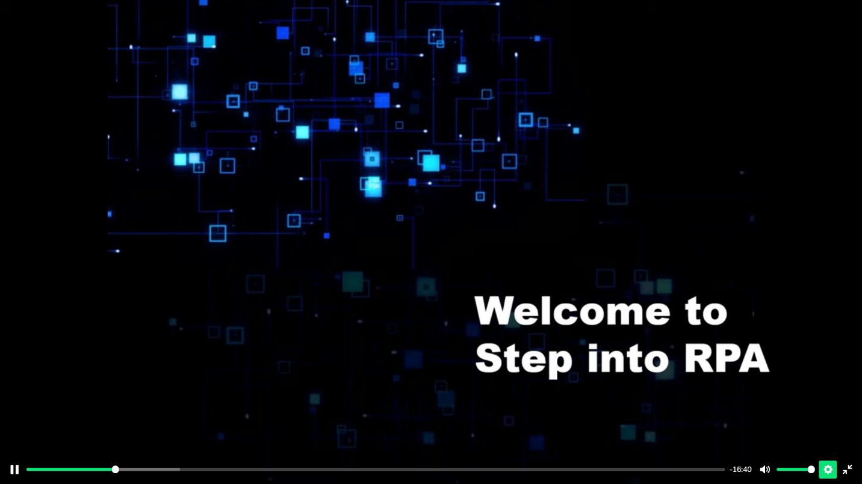

Robotic Process Automation (RPA) course is intended to introduce RPA to students. The course assumes no prior knowledge of RPA. The course takes a use-case approach. It begins by defining a real-world, generic problem and how it's solved in a non-RPA environment. The course goes on to teach skills that enable the students to create a robot using free UiPath software (Academic Alliance Edition) to automate the solution.

**Online coding:**

Problem 1: (using JAVA) Write a program in java, an array of integer data to be initialized. During the initialization, if a user enters a value other than integer value, then it will throw InputMismatchException exception. On the occurrence of such an exception, your program should print “You entered bad data.” If there is no such exception it will print the total sum of the array.

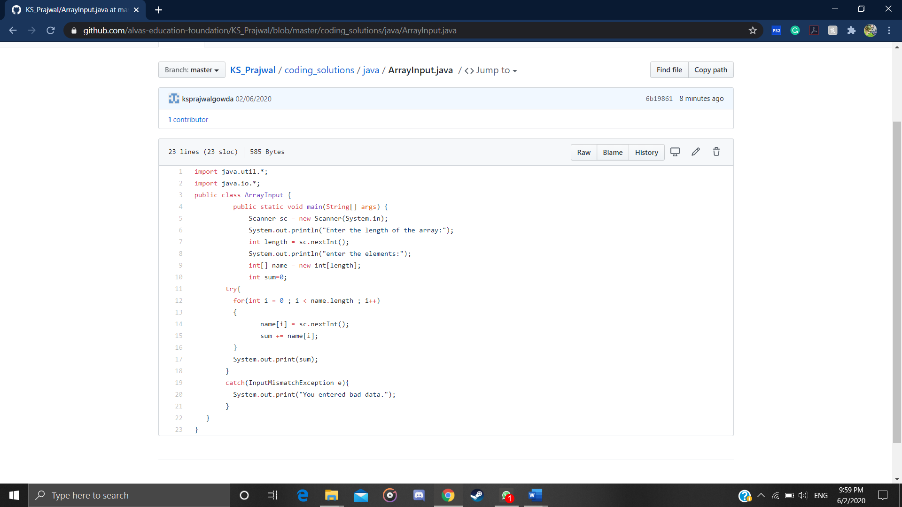

Problem 2: (using JAVA) Given an array arr[] of integers and an integer K, the task is to print all subsets of the given array with the sum equal to the given target K.

